20MCA136 – NETWORKING & SYSTEM ADMINISTRATION LAB Dept. of Computer Applications

NETWORKING & SYSTEM ADMINISTRATION LAB

Name: Vishnu Vijayakumar
Roll No:53
Batch: B
Date: 09-05-2022

Experiment No.: 15

Aim
Write a shell script to find sum of first 10 numbers.

Program
echo "enter the limit" read n
sum=0
for (( i=0;i<=n;i++ )) do
sum=$((sum + i)) done
echo "the sum of the entered number is " $sum

Output screenshot

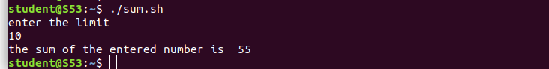

Amal Jyothi College of Engineering, Kanjirappally

